**MODEL BUILDING**

# Importing The Model Building Libraries

from tensorflow.keras.models import Sequential from tensorflow.keras.layers import Dense from tensorflow.keras.layers import LSTM

# Initializing The Model model

= Sequential()

# Adding LSTM Layers

model.add(LSTM(50,return_sequences = True, input_shape = (10,1))) model.add(LSTM(50,return_sequences = True)) model.add(LSTM(50))

# Adding Output Layers

model.add(Dense(1)) model.summary() Model: "sequential"

Layer (type) Output Shape Param #

=================================================================

|  |  |  |  |  |
| --- | --- | --- | --- | --- |
| lstm (LSTM) | (None, | 10, | 50) | 10400 |
| lstm_1 (LSTM) | (None, | 10, | 50) | 20200 |
| lstm_2 (LSTM) | (None, | 50) |  | 20200 |
| dense (Dense) | (None, | 1) |  | 51 |

=================================================================

Total params: 50,851

Trainable params: 50,851

Non-trainable params: 0

**Configure The Learning Process** model.compile(loss='mean_squared_error', optimizer = 'adam')

# Train The Model

model.fit(X_train, y_train, validation_data = (X_test, ytest), epochs

= 10, batch_size = 64, verbose = 1) Epoch 1/10

84/84 [==============================]

|  |  |  |  |
| --- | --- | --- | --- |
| - 8s | 33ms/step | - loss: | 0.0019 - |
| - 1s | 17ms/step | - loss: | 1.2329e- |
| * 1s * 1s | 17ms/step  18ms/step | * loss: * loss: | 1.2151e- |
| * 1s * 1s * 1s | 17ms/step  17ms/step  17ms/step | * loss: * loss: * loss: | 1.1884e- |
| - 1s | 17ms/step | - loss: | 1.1737e- |
| - 1s | 17ms/step | - loss: | 1.1241e- |
| - 1s | 17ms/step | - loss: | 1.1236e- |

val_loss: 9.9616e-04 Epoch 2/10

84/84 [==============================]

04 - val_loss: 7.3913e-04 Epoch 3/10

84/84 [==============================]

1.2148e04 - val_loss: 0.0014 Epoch 4/10

84/84 [==============================]

04 - val_loss: 7.6063e-04 Epoch 5/10

84/84 [==============================]

1.2602e04 - val_loss: 0.0020 Epoch 6/10

84/84 [==============================]

1.2412e04 - val_loss: 0.0011 Epoch 7/10

84/84 [==============================]

04 - val_loss: 7.1855e-04 Epoch 8/10

84/84 [==============================]

04 - val_loss: 7.6043e-04 Epoch 9/10

84/84 [==============================]

04 - val_loss: 9.7294e-04 Epoch 10/10

84/84 [==============================]

04 - val_loss: 6.5660e-04

<keras.callbacks.History at 0x2505dbb7970>

# Model Evaluation

train_predict=model.predict(X_train) test_predict=model.predict(X_test)

167/167 [==============================] - 2s 3ms/step

90/90 [==============================] - 0s 3ms/step

train_predict = scaler.inverse_transform(train_predict) test_predict = scaler.inverse_transform(test_predict) import math from sklearn.metrics import mean_squared_error math.sqrt(mean_squared_error(y_train,train_predict)) 28.851078372476536

# Save The Model

from tensorflow.keras.models import load_model model.save("Crude_oil.h5")

# Test The Model

look_back = 0

trainPredictPlot = np.empty_like(data_oil) trainPredictPlot[:,

:] = np.nan

trainPredictPlot[look_back:len(train_predict) + look_back, :] = train_predict

testPredictPlot = np.empty_like(data_oil) testPredictPlot[:,:]

= np.nan

testPredictPlot[len(train_predict)+(look_back*2)+1: len(data_oil)-1,

:] = test_predict

plt.plot(scaler.inverse_transform(data_oil)) plt.plot(trainPredictPlot) plt.plot(testPredictPlot) plt.title("Testing The Model") plt.show()

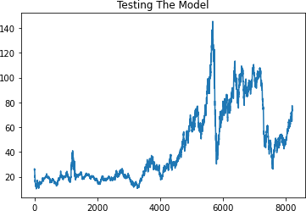

len(test_data) 2876

x_input = test_data[2866:].reshape(1,-1) x_input.shape (1, 10)

temp_input = list(x_input) temp_input = temp_input[0].tolist() temp_input [0.44172960165852215,

0.48111950244335855,

0.49726047682511476,

0.4679401747371539,

0.4729749740855915,

0.47119798608026064,

0.47341922108692425,

0.4649785280616022,

0.4703835332444839,

0.47149415074781587]

lst_output = [] n_steps = 10 i=0 **while**(i<10): **if**(len(temp_input)>10): x_input = np.array(temp_input[1:]) print("{} day input {}".format(i,x_input)) x_input = x_input.reshape(1,-1) x_input = x_input.reshape((1,n_steps, 1))

yhat = model.predict(x_input, verbose = 0) print("{} day output {}".format(i,yhat)) temp_input.extend(yhat[0].tolist())

temp_input = temp_input[1:] lst_output.extend(yhat.tolist()) i=i+1 **else**: x_input = x_input.reshape((1, n_steps,1)) yhat = model.predict(x_input, verbose = 0) print(yhat[0])

temp_input.extend(yhat[0].tolist()) print(len(temp_input)) lst_output.extend(yhat.tolist()) i=i+1 [0.47125974]

11

1 day input [0.4811195 0.49726048 0.46794017 0.47297497 0.47119799

0.47341922

0.46497853 0.47038353 0.47149415 0.47125974]

1 day output [[0.47265336]]

2 day input [0.49726048 0.46794017 0.47297497 0.47119799 0.47341922

0.46497853

0.47038353 0.47149415 0.47125974 0.47265336]

2 day output [[0.4715367]]

3 day input [0.46794017 0.47297497 0.47119799 0.47341922 0.46497853

0.47038353

0.47149415 0.47125974 0.47265336 0.4715367 ]

3 day output [[0.46978694]]

4 day input [0.47297497 0.47119799 0.47341922 0.46497853 0.47038353

0.47149415

0.47125974 0.47265336 0.4715367 0.46978694]

4 day output [[0.4700314]]

5 day input [0.47119799 0.47341922 0.46497853 0.47038353 0.47149415

0.47125974

0.47265336 0.4715367 0.46978694 0.47003141]

5 day output [[0.4699089]]

6 day input [0.47341922 0.46497853 0.47038353 0.47149415 0.47125974

0.47265336

0.4715367 0.46978694 0.47003141 0.46990889]

6 day output [[0.46986535]]

7 day input [0.46497853 0.47038353 0.47149415 0.47125974 0.47265336

0.4715367

0.46978694 0.47003141 0.46990889 0.46986535]

7 day output [[0.46965963]]

8 day input [0.47038353 0.47149415 0.47125974 0.47265336 0.4715367

0.46978694

0.47003141 0.46990889 0.46986535 0.46965963]

8 day output [[0.4699126]]

9 day input [0.47149415 0.47125974 0.47265336 0.4715367 0.46978694

0.47003141

0.46990889 0.46986535 0.46965963 0.46991259]

9 day output [[0.46976325]]

day_new = np.arange(1,11) day_pred

= np.arange(11,21) len(data_oil) 8216

plt.plot(day_new,scaler.inverse_transform(data_oil[8206:])) plt.title("Review Of Prediction") plt.plot(day_pred,scaler.inverse_transform(lst_output)) plt.show()

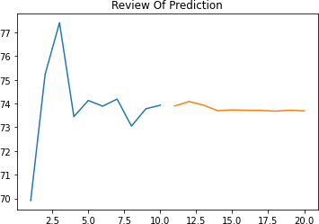

df3 = data_oil.tolist() df3.extend(lst_output) plt.title("Past Data & Next 10 Days Output Prediction") plt.plot(df3[8100:])

[<matplotlib.lines.Line2D at 0x250696187c0>]

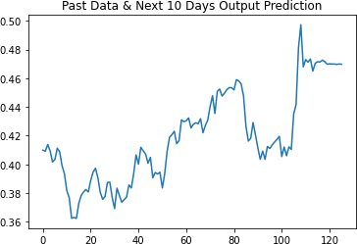

df3 = scaler.inverse_transform(df3).tolist()

plt.title("Past Data & Next 10 Days Output Prediction After Reversing The Scaled Values") plt.plot(df3)

[<matplotlib.lines.Line2D at 0x25069758a30>]

